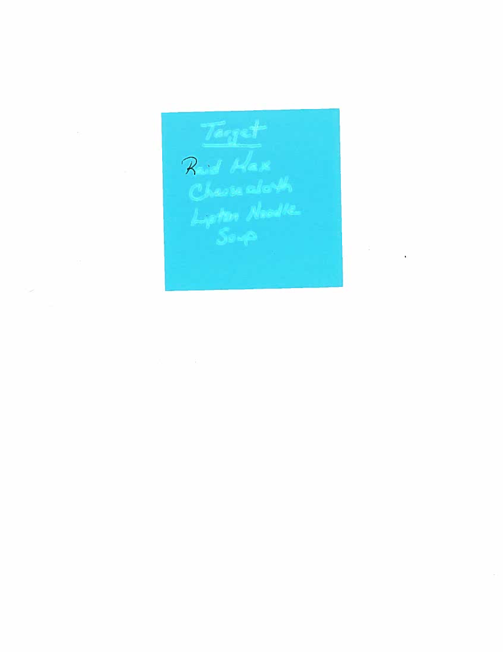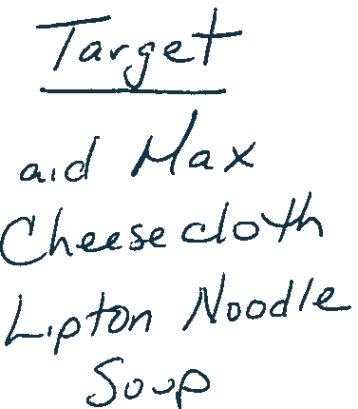

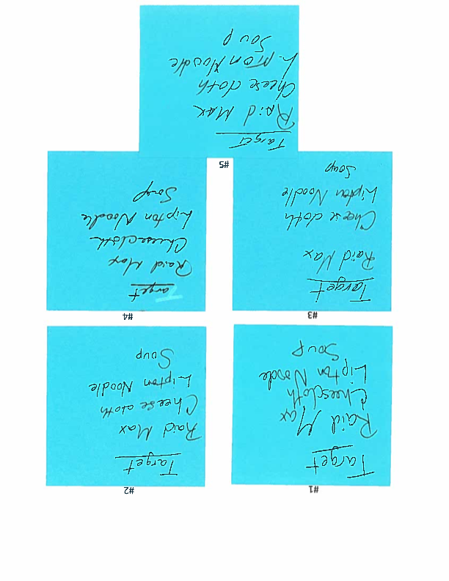
Look at the following questioned document. Compare it to the known exemplars and make a decision as to which exemplar best matches the questioned document. Discuss in no less than 350 words why you choose that exemplar and why you didn't choose the other exemplars.

